**Project Planning Phase**

**Project Planning Template (Product Backlog, Sprint Planning, Stories, Story points)**

|  |  |
| --- | --- |
| Date | 27 JUNE 2025 |
| Team ID | LTVIP2025TMID31213 |
| Project Name | EDUTUTOR-AI-PERSONALIZED-LEARNINGWITH-GENERATIVE-AI-AND-LMS-  INTEGRATION |
| Maximum Marks | 5 Marks |

**Product Backlog, Sprint Schedule, and Estimation (4 Marks)**

Use the below template to create product backlog and sprint schedule

|  |  |  |  |  |  |  |
| --- | --- | --- | --- | --- | --- | --- |
| **Sprint** | **Functional**  **Requirement (Epic)** | **User Story**  **Number** | **User Story / Task** | **Story Points** | **Priority** | **Team**  **Members** |
| Sprint-1 | Registration | USN-1 | As a user, I can register for the application by entering my email, password, and confirming my password. | 2 | High | Alice,Bob |
| Sprint-1 | Registration | USN-2 | As a user, I will receive confirmation email once I have registered for the application | 1 | High | Bob,Charlie |
| Sprint-2 | Dashboard | USN-3 | As a user, I can register for the application through Facebook | 2 | Low | Alice |
| Sprint-1 | Dashboard | USN-4 | As a user, I can register for the application through Gmail | 2 | Medium | Charlie |
| Sprint-1 | Login | USN-5 | As a user, I can log into the application by entering email & password | 1 | High | Alice,David |
|  | Dashboard |  |  |  |  | Bob,Charlie |
|  |  |  |  |  |  |  |
|  |  |  |  |  |  |  |

**Project Tracker, Velocity & Burndown Chart: (4 Marks)**

|  |  |  |  |  |  |  |
| --- | --- | --- | --- | --- | --- | --- |
| **Sprint** | **Total Story Points** | **Duration** | **Sprint Start Date** | **Sprint End Date**  **(Planned)** | **Story Points**  **Completed (as on**  **Planned End Date)** | **Sprint Release Date**  **(Actual)** |
| Sprint-1 | 20 | 6 Days | 24 Oct 2022 | 29 Oct 2022 | 5 | 2025-05-31 |
| Sprint-2 | 20 | 6 Days | 31 Oct 2022 | 05 Nov 2022 | 8 | 2025-05-31 |
| Sprint-3 | 20 | 6 Days | 07 Nov 2022 | 12 Nov 2022 | 4 | 2025-05-31 |
| Sprint-4 | 20 | 6 Days | 14 Nov 2022 | 19 Nov 2022 | 3 | 2025-05-31 |
|  |  |  |  |  |  |  |
|  |  |  |  |  |  |  |
|  |  |  |  |  |  |  |
|  |  |  |  |  |  |  |

**Velocity:**

Imagine we have a 10-day sprint duration, and the velocity of the team is 20 (points per sprint). Let’s calculate the team’s average velocity (AV) per iteration unit (story points per day)

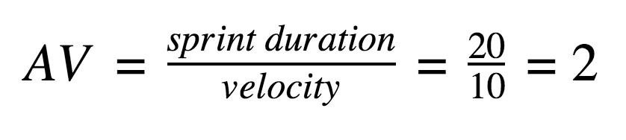

**Burndown Chart:**

A burn down chart is a graphical representation of work left to do versus time. It is often used in agile [software development m](https://www.visual-paradigm.com/scrum/what-is-agile-software-development/)ethodologies such as [Scrum.](https://www.visual-paradigm.com/scrum/scrum-in-3-minutes/) However, burn down charts can be applied to any project containing measurable progress over time.

